EXERCISE-1
Create a Spring Web Project using Maven

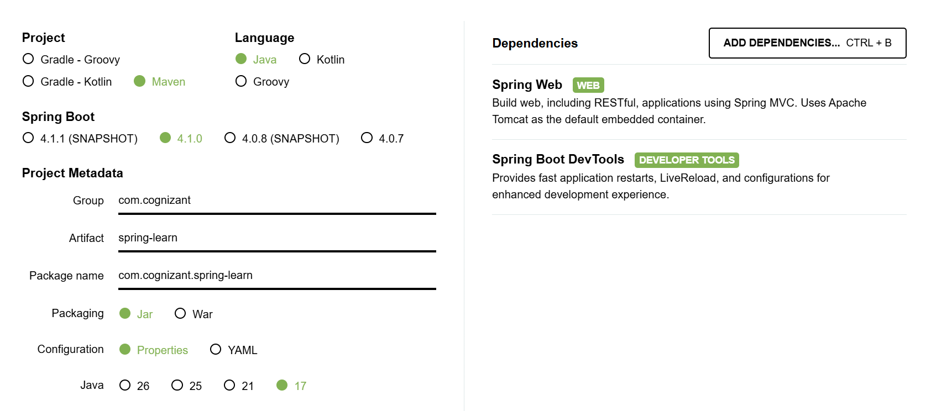
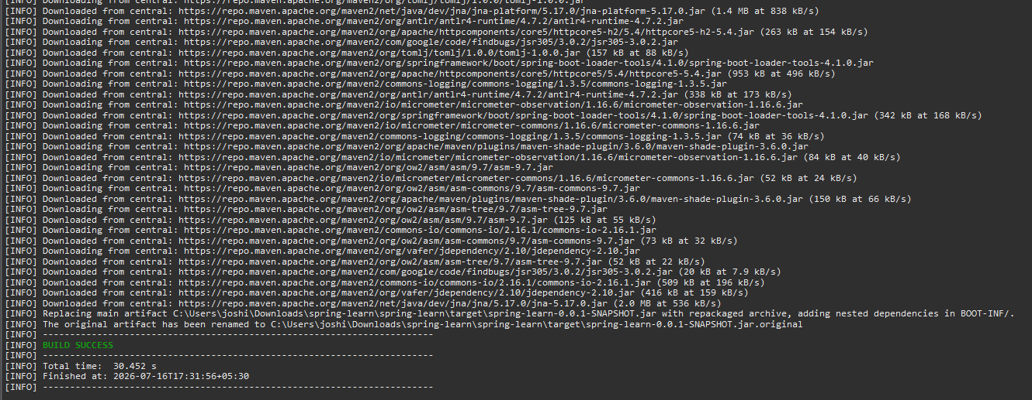
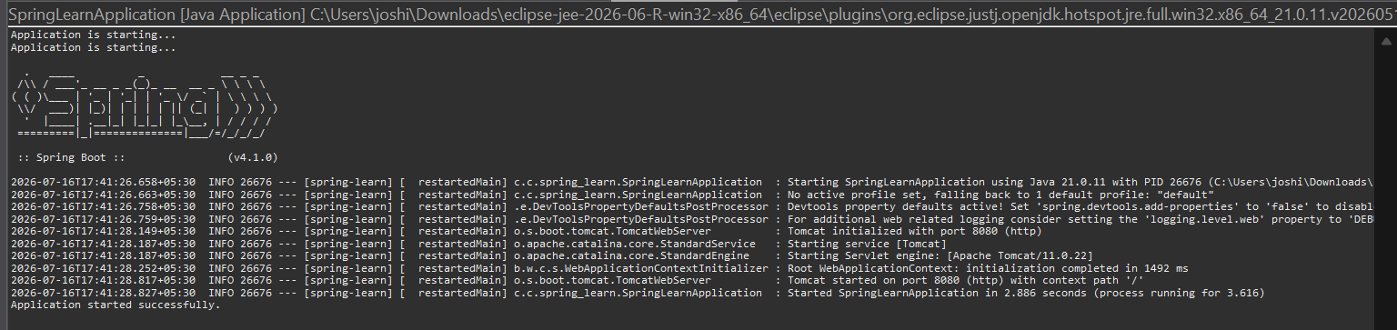
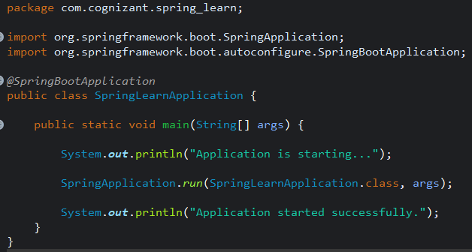

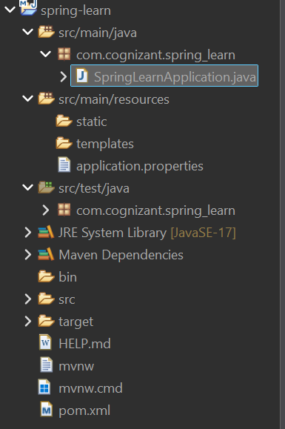

Pom.xml:
<?xml version="1.0" encoding="UTF-8"?>
<project xmlns="http://maven.apache.org/POM/4.0.0" xmlns:xsi="http://www.w3.org/2001/XMLSchema-instance"
xsi:schemaLocation="http://maven.apache.org/POM/4.0.0 https://maven.apache.org/xsd/maven-4.0.0.xsd">
<modelVersion>4.0.0</modelVersion>
<parent>
<groupId>org.springframework.boot</groupId>
<artifactId>spring-boot-starter-parent</artifactId>
<version>4.1.0</version>
<relativePath/> <!-- lookup parent from repository -->
</parent>
<groupId>com.cognizant</groupId>
<artifactId>spring-learn</artifactId>
<version>0.0.1-SNAPSHOT</version>
<name/>
<description/>
<url/>
<licenses>
<license/>
</licenses>
<developers>
<developer/>
</developers>
<scm>
<connection/>
<developerConnection/>
<tag/>
<url/>
</scm>
<properties>
<java.version>17</java.version>
</properties>
<dependencies>
<dependency>
<groupId>org.springframework.boot</groupId>
<artifactId>spring-boot-starter-webmvc</artifactId>
</dependency>

<dependency>
<groupId>org.springframework.boot</groupId>
<artifactId>spring-boot-devtools</artifactId>
<scope>runtime</scope>
<optional>true</optional>
</dependency>
<dependency>
<groupId>org.springframework.boot</groupId>
<artifactId>spring-boot-starter-webmvc-test</artifactId>
<scope>test</scope>
</dependency>
</dependencies>

<build>
<plugins>
<plugin>
<groupId>org.springframework.boot</groupId>
<artifactId>spring-boot-maven-plugin</artifactId>
</plugin>
</plugins>
</build>

</project>

